1. HOLLOW SQUARE WITH \*

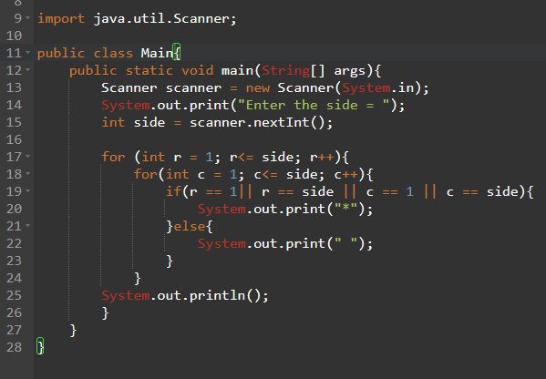

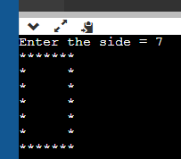

1. GET USER INPUT FOR YEAR AND MONTH AND SPECIFY THE NUMBER OF DAYS IN THE MONTH FOR THAT YEAR.

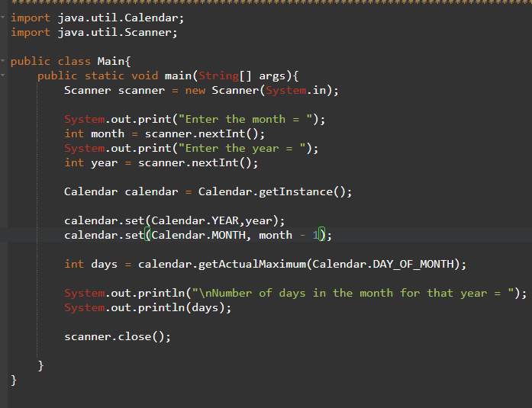

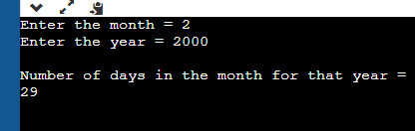

1. TAKE TWO ARRAYS, IF THEIR SUM IS SAME THEN PRINT TRUE AND IF THEIR SUM IS DIFFERENT THEN PRINT FALSE

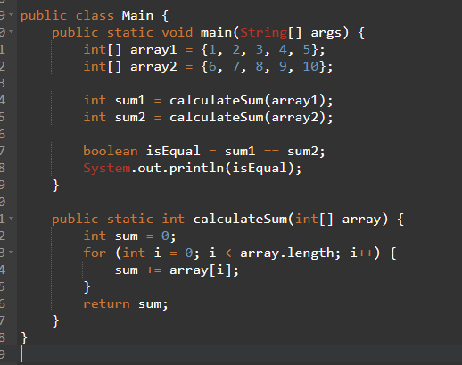



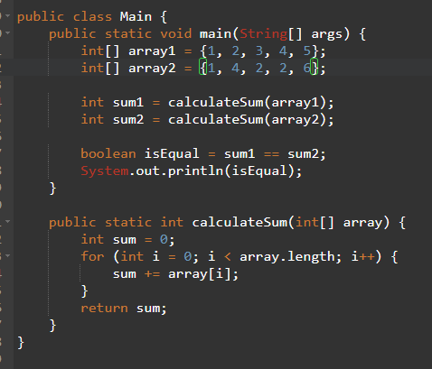



1. YOU HAVE A 2D MATRIX GIVEN BELOW AND YOU HAVE TO PRINT THE SUM IN A ZIG ZAG PATTERN

MATRIX =1 2 3

4 5 6

7 8 9

THAT MEANS FIND SUM OF 1 2 3 5 7 8 9.

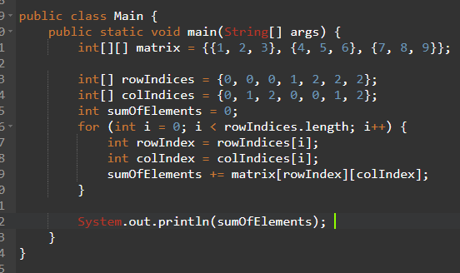



1. TRANSPOSE A MATRIX

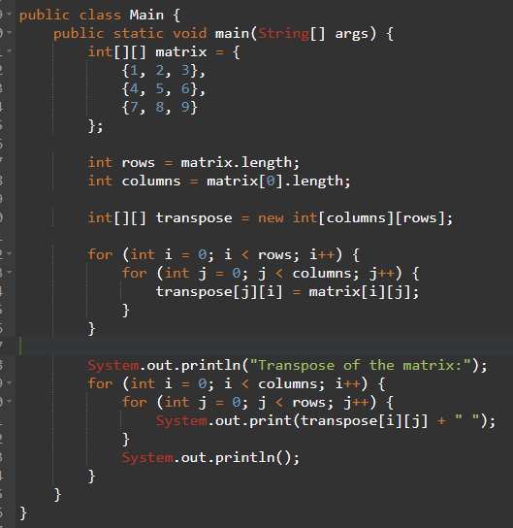

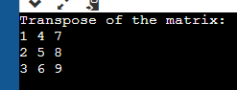

1. COMPATIBILITY CHECK

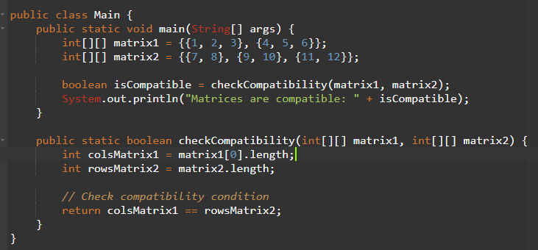



1. PRINT EVEN SUM AND ODD SUM OF AN 1D ARRAY

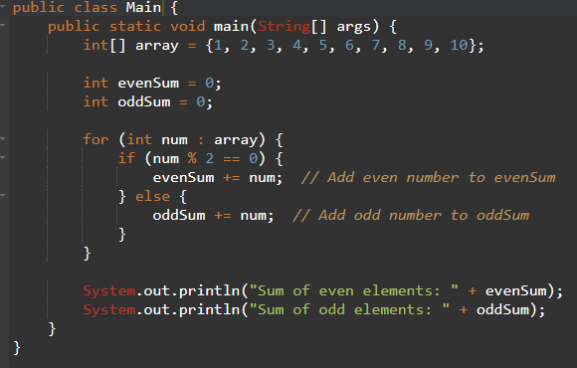



1. UNIFORMITY MATRIX

